**NPA Letter Jacket Order Form**

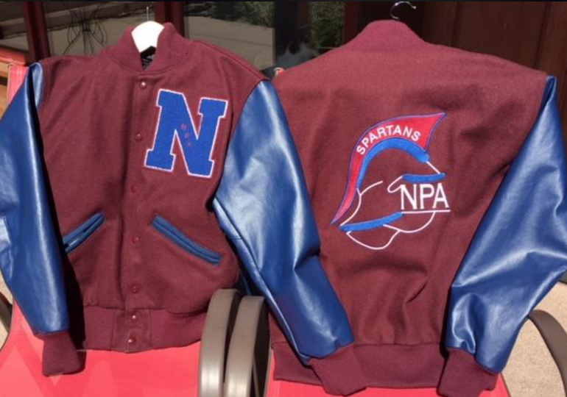

**Wool Jacket Sizing Chart**

**Size Chest Sleeve**

XS 30-32 34.00”

S 34-36 34.62”

M 38-40 35.62”

L 42-44 36.38”

XL 46-48 36.75”

2XL 50-52 37.25”

3XL 54-56 38.38”

The NPA letter jacket comes with a wool body, vinyl sleeves and a nylon lining. The NPA chenille letter your child has earned will be stitched onto the left-hand side of the jacket, your child’s name will be embroidered onto the front right and an NPA Spartan will be embroidered on the back side of the jacket. See the sizing chart for specific sizing.

If you are interested in ordering a letter jacket, please fill out this order form, include a check made out to NPA for $230, and put these items with your child’s chenille NPA letter in a Ziplock bag. The bottom portion of this form, the check, and the chenille letter must be turned in to Mrs. Kasprzyk by Monday, September 9th. Thank you!

Application of the patches and embroidery is done through Nuido Embroidery, which NPA will handle.

NPA has a size medium jacket on hand for size reference if you would like to try it on before ordering.

----------------------------------------------------------------------------------------------------------------------------------------------------------------

Parent name: _______________________________________________________________________________

Parent phone number: _______________________________________________________________________

Parent email: _______________________________________________________________________________

Check # (made out to NPA) & amount: __________________________

NPA Student name: __________________________________________________________________________

Name you would like embroidered onto jacket: ____________________________________________________

Letter jacket size: _____________ NPA Letter included: _____________