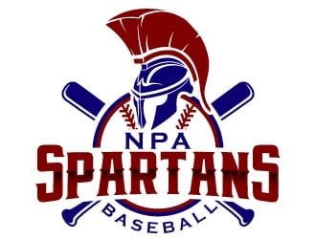

NPA Baseball 2022

Parent Group Chat via GroupMe
https://app.groupme.com/join_group/85577912/nvekh8Wy
- Get the latest updates about any changes to games or practices.
- GroupMe app
GameChanger Sign-Up
https://gc.com/teammanager/team/91dcaaeb-e0f5-4109-af63-b0f7fcbb5dea
- Stay up to date with games with live scores on the Game Changer app.
- Play by Play
Game Schedule via AZPreps365
https://www.azpreps365.com/teams/baseball/3045-north-prep/136627-varsity
- Current game schedule, rankings, standings, and tournament information.

Van Driver Sign-Up
https://www.signupgenius.com/go/10c0e4caeab23a2ffce9-2022
- The NPA baseball team will need 2 drivers for each away game.
- Let me know if you’re taking your player home from games or driving them to the game.

Eligibility
- 2 D’s or 1 F is considered ineligible for games.

