NPA New Student Onboarding

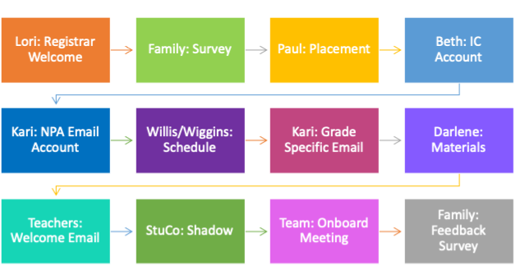

Teacher Role

1. Compose a welcoming note to your new student and their family that gives a little information about your class and the Classroom Join code & Zoom link. If you save a draft with all the codes and links, you can delete the unnecessary ones and give them targeted information. There is a template attached, but we encourage you to write your own version so the student doesn’t receive seven identical letters.
2. Attend the team meeting. The purpose of this is informational and to help put faces to the email addresses. Be prepared to discuss which essential assignments you expect students to complete.

Hello [new student’s name]!

Welcome to NPA! We recognize that this is a weird time to be joining a new school and are hoping to streamline the process as much as possible. Below you will find information to access [Teacher’s name]’s class.

There is not a need to meet unless you would like to clarify anything below:

Do you have the class codes for access?   Rather than just give it to you I will walk you through the process of finding teacher information.

* Go to the NPA website.  <http://northlandprep.org/>
* Under Academics click on “meet the teachers” you will see ALL the teachers listed.
* Look for me and click.
* [Enter other information that relates to accessing your class]

In addition to this information, we realize that human connection is extremely valuable and helpful in the learning process. Please feel free to join me for office hours on [enter office hours]. It would be nice to put a face to a name and see how I can best support you as you transition to NPA. You are also welcome to email me at [enter email] with any questions, comments, and concerns.

If you are having trouble accessing Infinite Campus, your school email, or need to talk to a counselor. Here is information that will help you:

Carol Willis-Program Coordinator/Counselor: [cwillis@northlandprep.org](mailto:cwillis@northlandprep.org)

Gianna Wiggins – School Counselor (Works mostly with MS): [gwiggins@northlandprep.org](mailto:gwiggins@northlandprep.org)

Kari Kazpryzk – Front Office/Online Guru : [kkazpryzk@northlandprep.org](mailto:kkazpryzk@northlandprep.org)

Lori McGaughey – Registrar: [lmcgaughey@northlandprep.org](mailto:lmcgaughey@northlandprep.org)

Additionally, we encourage you to go to Northlandprep.org > Students > Clubs & Activities to check out the clubs we are offering during this time. We all need social interaction and support and there are many options on ways to be involved at NPA and specifically, with your peers. Again, we welcome you and hope that your school year will go well.

[sign off],

[Teacher name]