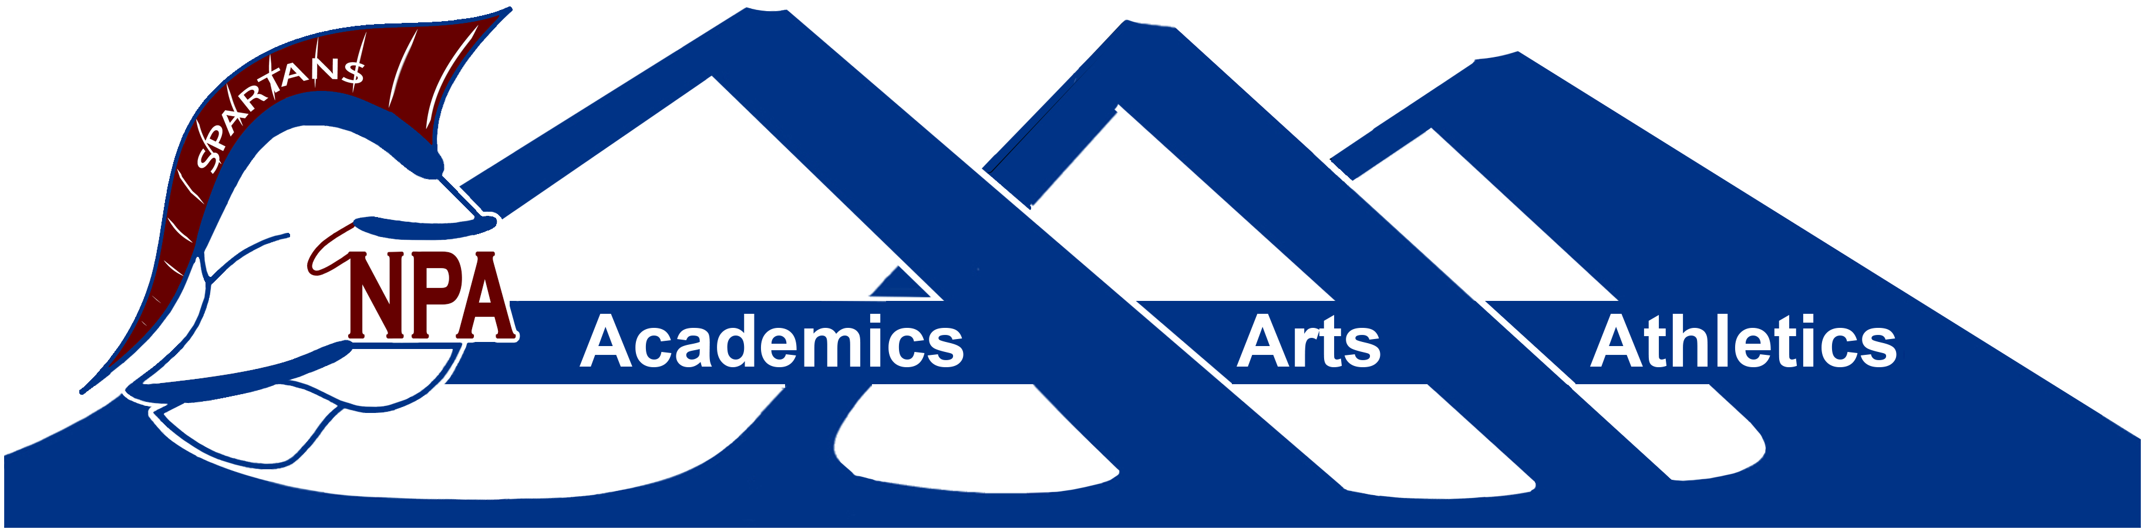

**Northland Preparatory Academy is pleased to introduce a new communications tool called Anonymous Alerts®.**

**What is the Anonymous Alerts app?**

The Anonymous Alerts anti-bullying and safety app reporting system helps combat bullying and other negative activity in schools by empowering students to speak up. Social and peer pressure are some of the hardest obstacles for students to overcome.

The system allows for 1-way or 2-way anonymous encrypted communications between submitters (students, parents or community members) and district administration and/or school staff. Users of the system have the option to remain anonymous or reveal their identity when submitting a report.

**How does it work?**

To use this revolutionary new app, students, parents or other school personnel can simply visit the

Northland Preparatory Academy website and click on the “Anonymous Alerts” button or text link to submit a report expressing their concern. Anonymous Alerts® mobile applications can be downloaded directly from the Apple, Google Play or the Chrome stores.

Northland Preparatory Academy supplies students an activation code, making the app remarkably easy to use and students select which school the message should go to. In addition, informational posters explaining how to use the app will be displayed throughout schools and offices in the district.

To send reports from the Web/Internet go to: <https://report.anonymousalerts.com/npa>

To send a report from your phone:

* Download the Anonymous Alerts® app for free from the Apple Store, Google Play store, or the Chrome store
* Start the App, enter **activation code: npa**
* Send important reports to school officials
* Add a screenshot, photo or video about the incident

**In an emergency, *always call 9-1-1!***

**Anonymous Alerts Overview Video**

[**https://www.youtube.com/watch?time_continue=1&v=LiSiokYnVnw**](https://www.youtube.com/watch?time_continue=1&v=LiSiokYnVnw)