**2019**

Samantha Carpenter MS, ATC, LAT

2019



***Northland Prepatory Academy***

***EMERGENCY ACTION PLAN***

**NPA EAP INDEX**

**INDEX**………………………………………………………………………………………………………………………………………...2

Emergency Personnel and Duties (General) …………………..…………………………………………………………….3

Emergency Phone List ………………………………………………………………………………………………………………...4

Secondary Personnel Contact Information ………………………………………………………………………………..5-6

General Emergency Procedures ………………………………………………………………………………………………7-8

Procedures for Calling 9-1-1 ……………………………………………………………………………………………………… 9

Map to NPA ……………………………………………………………………………………………………………………………...10

Maps of Facilities …………………………………………………………………………………………..……………….....11-14

Lightening Safety Protocol ………………………………………………………………………………………………………...15

Guidelines for CPR and Emergency Cardiovascular Care ………………………………………….……………16-17

K-12 Sports Concussion Protocol ……………………………………………………………………………………………18

1. **Emergency Plan Personnel**
   1. Primary Personnel **(SEE PHONE LIST)**

Certified Athletic Trainer

* + - Samantha Carpenter, MS, ATC, LAT

Physicians

* Director of Sports Medicine: Torey Botti, MD
  1. Secondary Personnel

NPA Administration

* + Athletic Director-Mike Elder
  + Principal-Toni Keberlein
  + Assistant Principal- Vada Visockis
  + Superintendent- David Lykins

NPA Coaches – (SEE SECONDARY PERSONNEL CONTACT LIST)

Outside Physicians (SEE EMERGENCY PHONE LIST)

1. **Duties of Emergency Response Team (SEE PROCEDURES)**
   1. *Supervisor and Facilitator (ATC, AD, ASSISTANT PRINCIPAL, HEAD COACH)*
2. Responsible to take charge of situation.
3. Determine if life-threatening situation exists.
4. Provide emergency care (see Appendix A for AHA CPR, AED, First Aid Guidelines).
5. Organize team members.
6. Inform/contact Director of Sports medicine if they are not on site.
7. Document incident.
8. Follow-up and review incident and management.
   1. *Emergency Care Provider(s)(MD, ATC, EMS)*
9. Calm and reassure the athlete.
10. Help assess the injury.
11. Provide appropriate first aid/CPR as needed.
12. Release athlete to appropriate emergency medical personnel for transport.
13. Assist EMS as needed with transport.
    1. *Traffic Controller (AD, ASSISTANT PRINCIPAL, COACHES, BYSTANDER)*
14. Keep uninjured athletes and spectators away from scene.
    1. *EMS Contact (see 911 Call Sheet) (AD, ASSISTANT PRINCIPAL, COACHES, BYSTANDER)*
15. Activate EMS -**911**
16. Identify location and number of nearest phone to EMS operator.
17. Report nature and severity of injury to EMS operator.
18. Report number of victims and treatment rendered thus far.
19. Give specific directions to scene.
20. Give location of emergency vehicle escort.
21. Remain on phone until operator hangs up.
22. Inform emergency care providers of status of EMS assistance.
    1. *Emergency Vehicle Escort (AD, ASSISTANT PRINCIPAL, COACHES, BYSTANDER)*
23. Go to designated location to meet emergency vehicle.
24. Direct emergency vehicle to scene.
25. **Emergency Equipment/Protocols:** AED, Splints, Cervical Collar
26. **Emergency Transportation**

The Athletic Trainer/Sports Medicine Staff is not responsible for transporting any injured student-athlete. In the event that a student-athlete needs further emergency medical assistance, EMS will be summoned. A parent/guardian or coach with parental consent can transport the injured student-athlete only if he/she will not sustain further harm.

**NPA EMERGENCY PHONE LIST**

**EMS/FIRE/POLICE**  **911**

**CERTIFIED ATHLETIC TRAINER**

Samantha Carpenter, MS, ATC, LAT (cell) (520) 603-4374

**SPORTS MEDICINE CENTER PHYSICIANS**

Dr. Torey Botti, MD (928) 773-2280

Dr. Darius Moezzi, MD (928) 773-2280

Dr. Kevin O’Donnell, MD (928) 773-2280

**INJURY CARE CLINIC – *Same Day/Next Day Appointments***

FLAGSTAFF BONE AND JOINT (928) 773-2280

77 W FOREST AVE SUITE 301

FLAGSTAFF, AZ

*OPEN 7 DAYS/WEEK, 8AM-5PM*

**URGENT CARE**

CONCENTRA URGENT CARE (928) 773-9695

1110 E ROUTE 66, SUITE 100,

FLAGSTAFF, AZ

NEXT CARE URGENT CARE (928) 779-3844

1000 N HUMPHREYS SUITE 104,

FLAGSTAFF, AZ

**HOSPITAL**

FLAGSTAFF MEDICAL CENTER (928) 779-3366

1200 N BEAVER ST

FLAGSTAFF, AZ

**NPA COACHES CONTACT INFORMATION**

|  |  |  |  |  |  |
| --- | --- | --- | --- | --- | --- |
| **Last** | **First** | **Sport** | **Position** | **Cell** | **email** |
|
| Raab | Scot | Swim & Dive | Head Coach | (229) 834-9709 | scotraab@gmail.com |
|
| Linder | Ryan | HS Cross Country | Co-Head Coach | (308) 520-2538 | rlinder@northlandprep.org |
|
| Perry | Carl | HS Cross Country | Co-Head Coach | 890-8156 | flagperry@gmail.com |
|
| Ulm | Jill | MS Cross Country | Head Coach | 853-3559 | majicaly@gmail.com |
|
| Ebersole | Lacey | HS Volleyball | Head Varsity Coach | 699-7832 | laceykx60@aol.com |
|
| Hovis | Keith | HS G. Soccer | Co-Head | 856-1782 | keith.hovis@nau.edu |
|
| Blair | Michael | HS G. Soccer | Co-Head | (480) 290-8860 | michael.blair@flagstaffrevolution.com |
|
| Carillo | Erik | HS B. Soccer | Head Coach | 525-4917 | carrilloerik@gmail.com |
|
| Kuhn | Wendy | HS & MS MTB | Co-Head Coach | 699-1823 | flagroadie@gmail.com |
|
| Kuhn | Jim | HS & MS MTB | Co-Head Coach | 821-6945 | wendy@gcmarketinggroup.com |
|
| Hartsock | Leopold | Wrestling | Assistant Coach | (910) 264-9895 | lhartsock@northlandprep.org |
|
| Stanton | Ben | Westling | Head Coach | 607-1759 | ben.stanton@stantax.net |
|
| Hines | Jeff | MW Wrestling | Assistant Coach | 226-8946 | jhines@northlandprep.org |
|
| Harris | TJ | HS B Baskeball | Head Varsity Coach | 460-1908 | tharris@northlandprep.org |
|
| Harris | TJ | HS G Basketball | Head Coach | 255-0598 | tharris@northlandprep.org |
|
|  |  | HS G Basketball | Assistant Coach | 856-1782 |  |
|
| Schmidt | Matt | HS Baseball | Head Coach | 225-0598 | pmswjsdad@aol.com |
|
| Johnson | Ryan | HS Baseball | Assistant Coach |  |  |
|  |
| Dean | Betty | Softball | Head Coach | 773-6500 | bjdean@wlgore.com |
|
| Talley | Justin | Softball | Assistant Coach | 310-8263 | talley.fgsll@gmail.com |
|
| Lacour | Beth | Golf | Head Coach | 607-2603 | BLaCour@northlandprep.org |
|
| Bailey | Matt | Golf | Vol. Assistant Coach | 864-6043 | mbailey@fhgc.com |
|
| Molkeke | Eric | HS B Tennis | Head Coach | (928) 864-9598 | emokelke@gmail.com |
|
| Kerr | Austin | HS G Tennis | Head Coach | (602) 757-9618 | akerr@northlandprep.org |
|
| Linder | Ryan | Track | Co-Head Coach | (308) 520-2538 | rlinder@northlandprep.org |
|
| Perry | Carl | Track | Co-Head Coach | 890-8156 |  |
|
| Mueller | Kurt | Track | Assistant Coach | 707-2304 | kmueller@northlandprep.org |
|
| Hughes | Mark | Track | Assistant Coach | (602) 358-6103 | mhughes@northlandprep.org |
|
| Donahoe | Belinda | MS Soccer-Boys | Head Coach | 607-4413 | bdonahoe@msn.com |
|
| Donahoe | Belinda | MS Soccer-Girls | Head Coach | 607-4413 | bdonahoe@msn.com |
|
| Moseng | Deja | MS Volleyball | Head Coach | 853-4799 | vuskie@hotmail.com |
|
| Jordan | Laurie | MS Volleyball | Head Frosh Coach |  | laurie.jordon@nau.edu |
|
| Winger | Carlie | MS Volleyball | Head Coach |  | carly@azharrislaw.com |
|
| Hanson | Brent | MS B Basketball | Cooridinator | 606-3110 | brent.hanson@empire-cat.com |
|
| Hayden | Dawn | MS Athletic Contact | 607-7286 | npaathletics@yahoo.com |  |
|  |

*Mike Elder*

Athletics/Activities Director

Northland Prepatory Academy

[melder@northlandprep.org](mailto:melder@northlandprep.org)

c. 928-380-6287 o. 928-214-8776

**NPA GENERAL EMERGENCY PROCEDURES**

In the event of a medical emergency the **on-duty physician (MD)**, **certified athletic trainer (ATC)**, or **emergency personnel (EMS)** will administer immediate emergency aid to the injured person.

*If none of the above are present*, then the **head coach** or **designated first aider** will assume responsibility.

The **parent/guardian/coach** will accompany the injured athlete to the hospital and remain until parents or designated administrator to arrive.

**Emergency Action Procedures/Protocols**

**ALL NPA ATHLETICS SITES**

2017

This plan is designed to guide those individuals that are responsible for emergency action, which may be required at Northland Prepatory Academy. This includes all athletes involved in athletic competition or practice sponsored by the Athletic Department.

**Emergency Medical Assistance should be summoned in any emergency situation including:**

* Possible head or neck injury
* Paralysis
* Possible heat stress/illness
* Open fracture or displaced closed fracture
* Unconsciousness
* If a player stops breathing

**Emergency Protocol for NPA**

1. Call 911

* **Certified Athletic Trainer** and **Coaches** should carry a cellular phone at all times and should be the first choice in activating EMS

1. Instruct emergency medical services (EMS) personnel to the site location.
2. Provide necessary information to EMS personnel:

* Name, address, telephone number of caller
* Number of victims; condition of victims
* First-aid treatment initiated
* Specific directions as needed to locate scene
* Other information as requested by dispatcher

1. Provide appropriate emergency care until arrival of EMS personnel
   * If necessary **first aid** or **CPR** will be rendered by **Certified Athletic Trainer** or **Coach**.
   * If needed, automated external defibrillators (AED) should be obtained and are located in the athletic training room.
2. **Head Coach / Games manager** will designate someone to wait on the ambulance at the student drop off roundabout and direct them to the site of the injured athlete.
3. On arrival of EMS personnel, provide pertinent information (method of injury, vital signs, treatment rendered, medical history) and assist with emergency care as needed.

Note: **Head coach/Games manager** will:

* Designate who should accompany student-athlete to hospital.
* Notify Certified Athletic Trainer (if not present) immediately.
* Give copy of Parents’ Information / Insurance Form kept in sports kit to EMS upon arrival.

**Certified Athletic Trainer/Sports Medicine Staff** will:

* Contact parents
* Inform coach(s) and administration
* Appropriate injury reports should be completed

**Calling 911:**

**This is to be displayed in the NPA Athletic Training Room and at all event sites so these steps may be followed in Emergency Situations.**

1. Remain Calm. This will aid the operator in receiving your information.

2. Dial 911! Remember, you may need to access an outside line first.

3. My name is ________________________________.

4. I need paramedics at Northland Preparatory Academy.

5. The exact address is _________________________________________ (FILL IN). The major cross street

is the _____________________ RD (FILL IN).

6. There is __________________________________ athlete(s) with a _________________________________ injury.

(How many athletes/victims) (Type/nature/severity)

7. The athlete is located at ___________________, which is on the ___________________ side of the

facility.

(activity area/venue) (North, West, etc.)

8. So far, __________________________________________________________________________________________________

(list care/treatment initiated for the athlete/victim and the athlete’s response/condition).

9. I am calling from _____________________________________________________________ (give phone number).

10. ______________________________________ (Name of personnel) will meet the ambulance/paramedics

at ___________________________________ (State specific location) and guide them to the injured

athlete.

11. Answer, calmly, any questions the operator may have. Wait until the operator hangs up

first.

**MAP TO NPA**

**ADDRESS: 3300 Sparrow Ave, Flagstaff, AZ 86004**

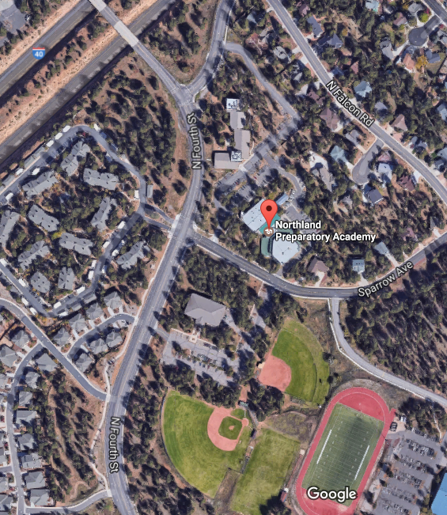

EXAMPLE

Emergency Action Procedures/Protocols

**NPA: Multipurpose Room**

1. The exact address is **3300 Sparrow Ave, Flagstaff, AZ 86004**
2. The major cross streets are **SOLIERE AVE AND N FOURTH ST**
3. **EMS** Instructions: (template): park at **NPA**, enter through, **SOLIERE ENTRANCE** personnel will meet you at **ENTRANCE TO THE BUILDING**

**SINAUGUA MIDDLE SCHOOL: Track & Field**

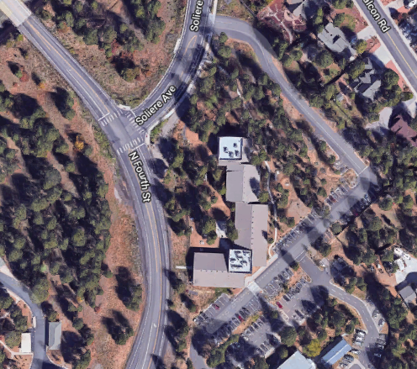

ENTER HERE

MEET HERE

Emergency Action Procedures/Protocols

1. The exact address is 3950 E Butler Ave, Flagstaff, AZ 86004
2. The major cross street is **SPARROW AVE**
3. **EMS** Instructions: (template): park at **PARKING LOT NEAR TRACK** enter through, **DRIVEWAY SOUTH OF SPARROW AVE (PARKING LOT WILL BE ON YOUR RIGHT)** personnel will meet you at **PARKING LOT.**

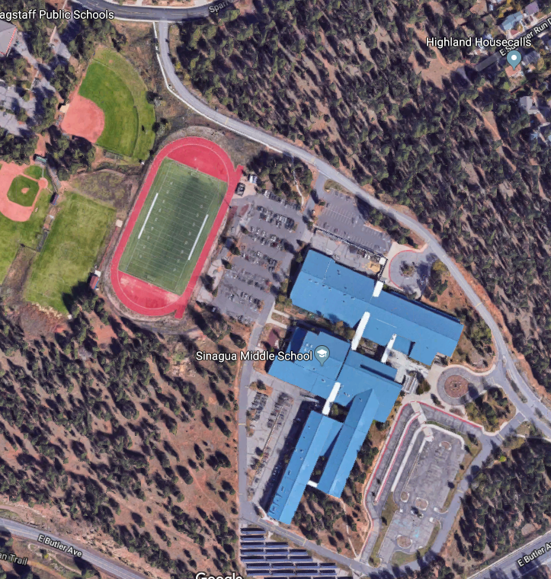

ENTER HERE

MEET HERE

**SINAGUA MIDDLE SCHOOL: Softball / Baseball**

Emergency Action Procedures/Protocols

1. The exact address is 3950 E Butler Ave, Flagstaff, AZ 86004. The major cross streets are **SPARROW AVE AND N FOURTH ST.**
2. **EMS** Instructions: (template): park at **FLAGSTAFF PUBLIC SCHOOLS**, enter through **PARKING LOT ON SPARROW AVE**  personnel will meet you at **PARKING LOT.**

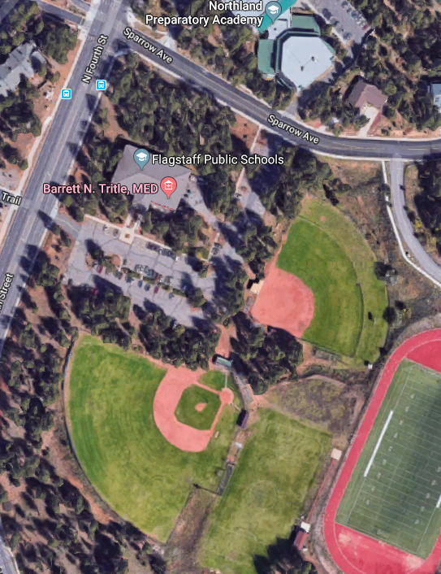

ENTER HERE

MEET HERE

**NPA GYMNASIUM: Gymnasium**

Emergency Action Procedures/Protocols

1. The exact address is **3300 Sparrow Ave, Flagstaff, AZ 86004**. The major cross streets are **SPARROW AVE AND N FOURTH ST.**
2. **EMS** Instructions: (template): park at **DRIVEWAY BY GYM DOORS**, enter through **ONE WAY ENTRANCE**  personnel will meet you at **GYM ENTRANCE.**

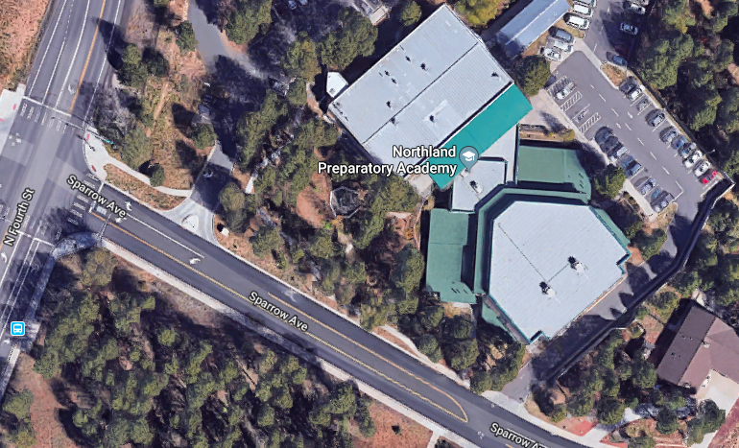

MEET HERE

ENTER HERE

**NPA LIGHTENING SAFETY PROTOCOL/PROCEDURES**

**NPA Athletics’ Lightning Safety Policy is based on:**

*The National Athletic Trainers’ Association Position Statement: Lightning Safety for Athletics and Recreation.*

*The NCAA Position Statement on Lightning Safety.*

In the event of severe weather when threatening lightning conditions are probable, at least one of the following two indicators of lightning location will be used as the recognized method of determining dangerous lightning situations:

*1. RELIABLE WEATHER APPLICATION/LIGHTNING DETECTOR*

*2. Flash to Bang counting method*

**Flash to Bang** method of determining proximity of lightning activity:

**STEP 1:** When you see lightning, start counting the seconds.

**STEP 2:** Stop counting when associated thunder (bang) is heard.

**STEP 3:** Divide this count by 5 to determine the distance of the lightning flash in miles

*Example*: If you count 30 seconds after flash till sound of thunder, divide 30 by 5 which equates to a distance of 6 miles (9.66 km).

**If lightning is seen and thunder is heard within 30 seconds or less of the flash, the referee/umpire should call a lightning delay and clear the field immediately.**

***NOTE: Lightning has been reported to strike 10 miles or more from where it originated.***

By these methods once lightning conditions are detected within **6 – 8 miles** of the practice or event site activity will have been suspended and all individuals will have been moved to a **safe shelter**.

Return to the activity site will not resume until **30 minutes** following the last indication of lightning conditions **within the 6 – 8 mile range**. If another strike is seen and thunder heard within 30 seconds, the clock restarts to 30 minutes of delay.

During practice, the **athletic trainer** on site will inform the head coach of threatening lightning conditions. If an athletic trainer is not on site the **head coach** will assume responsibility of monitoring threatening lightning conditions and immediately instructing the athletes to proceed to the **closest, safe, shelter**.

During NPA Home Events the **athletic trainer** on site will inform the game manager, officials and coaches of threatening lightning conditions and that play is to be suspended. Coaches and game officials will be made aware of the lightening safety by the athletic trainer at the **start of every athletic competition**.

All individuals have the right to leave an athletic site or activity, without fear of repercussion or penalty, in order to seek a safe structure or location if they feel they are in danger from impending lightning activity.

Individuals who feel their hair stand on end or skin tingle or hear crackling noises should assume the **lightning–safe position** ( i.e., crouched on the ground, weight on the balls of the feet, feet together, head lowered, and ears covered). Do not lie flat on the ground.

**Safe places** are in an enclosed building away from windows and electrical conducting materials as well as in vehicles with the windows rolled up.

***NOTE: Open shelters, dugouts, golf carts, and similar structures are not safe locations from lightning hazards.***

***NOTE: In any structure during a lightning storm all electrical conducting materials that are exposed to lightning are potentially unsafe and should be avoided: i.e. plumbing fixtures and pipelines, land line telephones, and electrical appliances.***

**AMERICAN RED CROSS**

***CPR AND EMERGENCY CARDIOVASCULAR CARE***

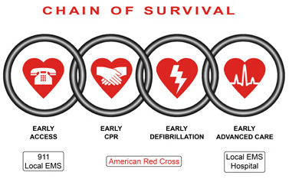

***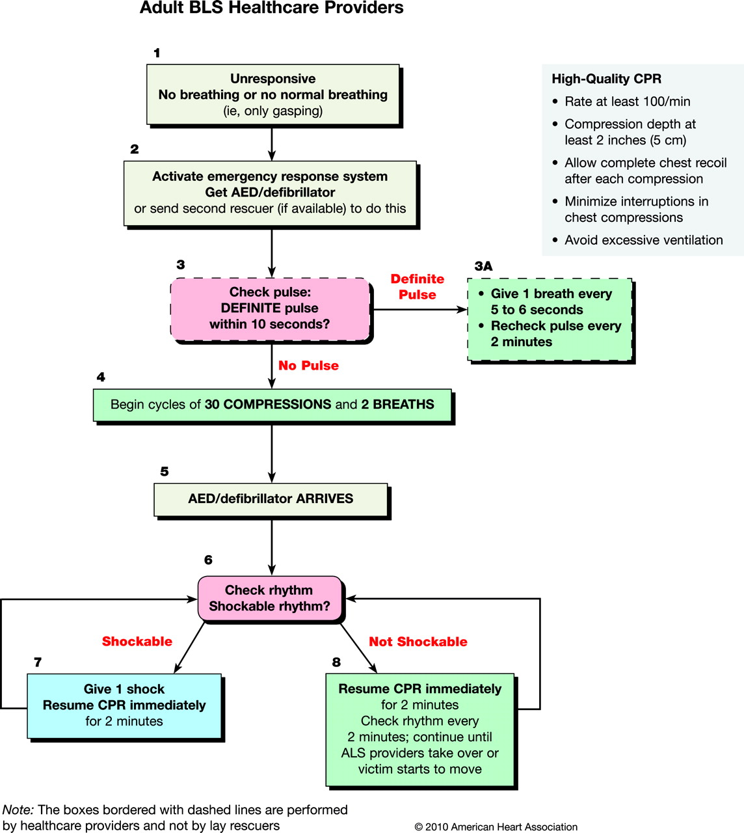*NPA Sports Concussion Protocol**

**When an Athlete Sustains a Concussion:**

Below are the Senate Bill 1521 (2011) requirements regarding concussions for those participating in interscholastic athletic activities:

**Step 1. Immediate removal from activity if concussion is suspected**

* A healthcare professional including athletic trainers, or a coach, official, or parent will remove an athlete from play if a concussion is suspected.

**Step 2. Referral to Health Care Provider**

* The athlete should see a health care provider to determine if he or she sustained a concussion and determine the course of treatment.
* “Health Care Provider” refers to a licensed: Physician, Athletic Trainer, Nurse Practitioner, or Physician Assistant.
* The athlete should be transported to the hospital if there is prolonged loss of consciousness, significant deterioration in mental status, or other significant injuries requiring medical attention.

**Step 3. Written clearance by a health care provider before athlete can return-to-play**

* The athlete cannot return to play or participate in any supervised team activities that involve physical exertion including games or practices ***until they have received written clearance*** from a healthcare provider (as defined above).
* See Return to Play below.

**NOTE: All Concussions must be REPORTED to the Athletic Trainer and Head Coach at NPA**

**Return to Play:**

ALL athletes must go through a return to play progression before being completely cleared for activity as recommended by the National Athletic Trainers’ Association Position Statement: Management of Sport Concussion. Before full return to play, the athlete must have a normal clinical examination and perform at or above preinjury levels of functioning on all objective concussion assessments (ie. ImPACT).

The following progression will begin once concussion-related symptoms are no longer present and the athlete is cleared to begin the progression by the athletic trainer and/or physician:

