Coconino Community College New Application Instructions
Step 1: Go to: www.coconino.edu/apply-now
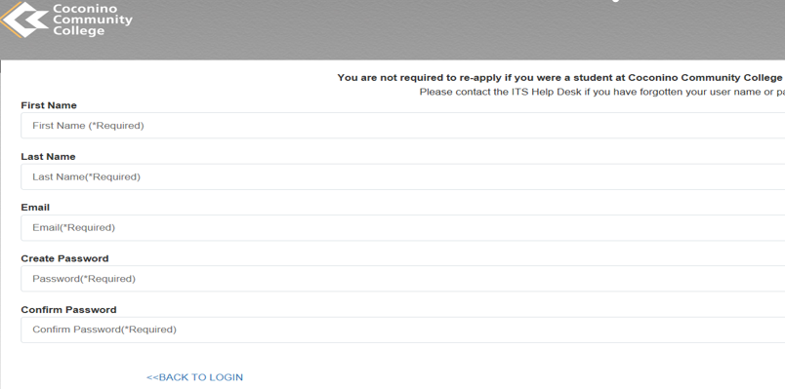
Step 2: Students will create a “portal” including first name, last name, email, and password. This portal will be used strictly for the application piece.
Step 3: Click “Start Now” to begin the application.
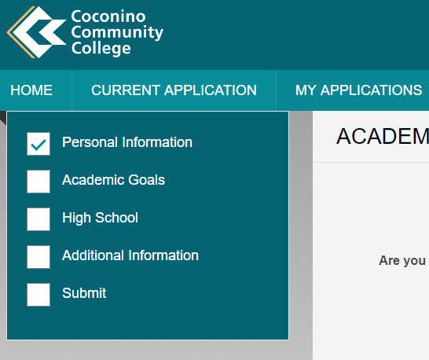
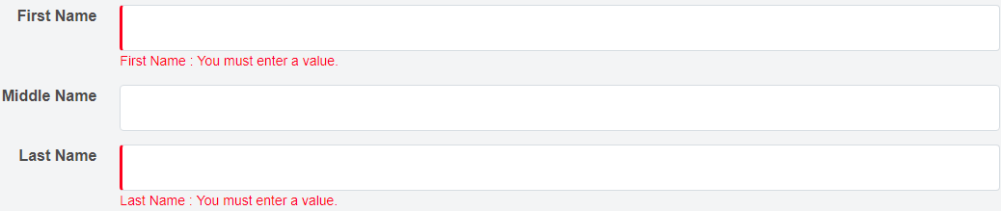
Step 4: Fill out the personal Information fields and then click “save and continue”. The red line in the answer boxes indicates a required field.

The check boxes on the left-hand side during the application indicates which areas are completed.

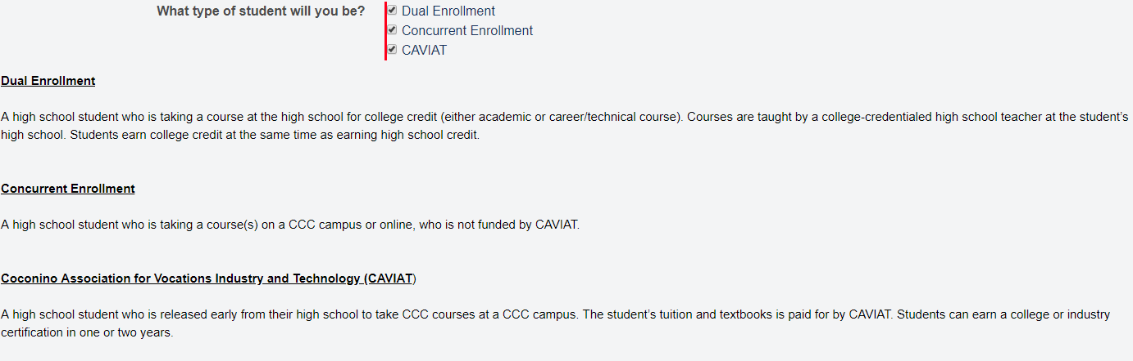
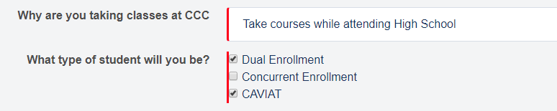
Step 5: Next students will arrive at the Academic Goals page. Students will fill out the correct information pertaining to their own goals. When they reach the question “Why are you taking classes at CCC?” they will check the correct box i.e. Dual Enrollment, Concurrent Enrollment, and/or CAVIAT. Information regarding each of these types of courses will pop up when a student checks any of the boxes.
Step 6: Next, it will ask “What area would you like to study” and “Please Select the degree or certificate you would like to pursue?”. Please choose from the area that you would most like to student at college.
Step 7: Next, students will fill out their high school information including name of school, current grade level, and unweighted GPA.
Step 8: The “Additional Information” page asks the applicant if they will be applying for Financial Aid, Disability Resources, if they have taken a placement test (ACT and SAT included), if they are a First-Generation student, and for their parent contact information.
Step 9: Lastly, students will reach the submission page. Students will need to agree to not submitting false information, and also indicate whether schools and colleges can share information regarding the students’ records i.e. if the student is first-generation and may qualify for scholarships.

